# Sales Coach Autonomous Agent Installation Guide

## Prepare for Installation

Create a SharePoint site to contain the transcription documents

Ensure you can add files into the Documents area of the site.

## Import the solution into a Power Platform Environment

Import the unmanaged solution: SalesCoachAgent_n_n_n_n.zip

Ensure all connection references are validated and created

Publish All Customizations

## Configure the Solution

### Update Power Automate Flow “When a transcript document arrives”

Set the Site values correctly

### Import Data

### Navigate to the “Active Sales Call Results” view and import data

Import the file “Import Sales Call Results.xlsx”

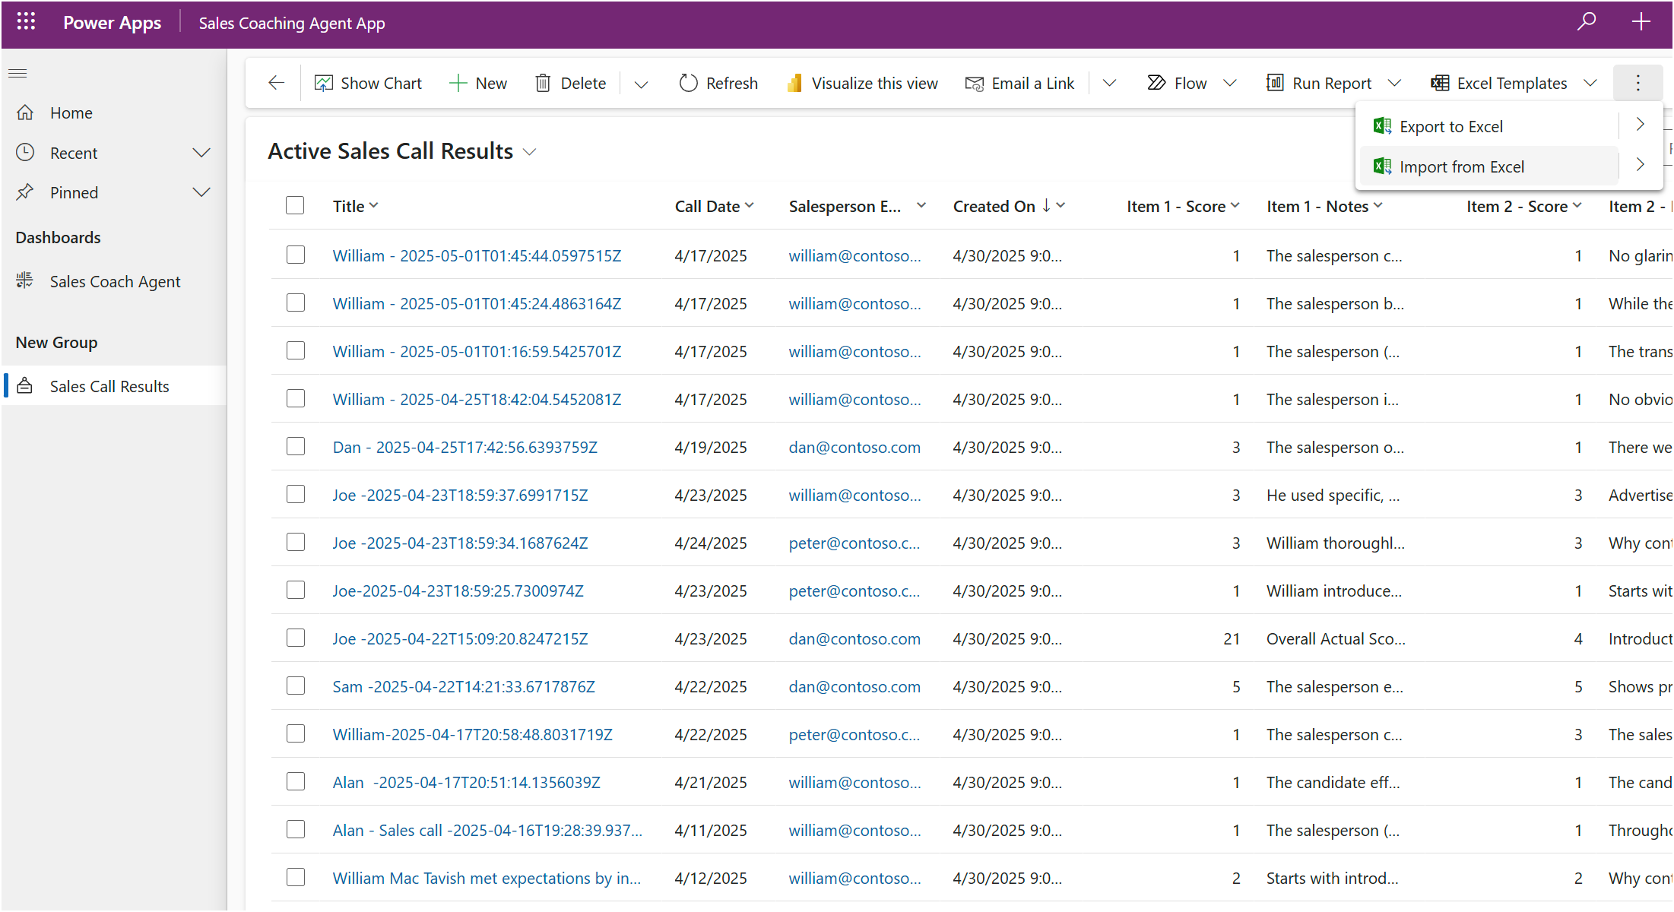

Update the “Call Date” as needed to a more recent date to show a smooth PBI report

## How To Trigger the Agent

To trigger the agent, upload the file *Transcript - Sales Call - Contoso.txt* to the SPO document repo.

## Review the video “The Solution Explanation Demo Explanation”

Review the video to understand the technical architecture, i.e. how the solution was built.

*Sales Coach Agent - Technical Overview - NOT customer demo.mp4*

## Use the Customer Demo video in lieu of Actual Demo

*Sales Coach Agent - Customer Demo.mp4*